Practical - 3
Practical Title: Responsive UI Design using CSS Grid, Flexbox, and Bootstrap/Tailwind

Problem Definition: Design responsive layouts for Home, About, Registration, Dashboard, and Events pages using CSS Grid and Flexbox. Optional to use CSS framework such as Bootstrap or Tailwind. Ensure mobile-first responsiveness.

Theory

How does the layout adapt for mobile, tablet, and desktop screens?
Answer: Using a mobile-first approach with CSS media queries — the base layout is a single-column stacked design for mobile, then min-width breakpoints (≥768px for tablet, ≥1024px for desktop) switch it to two-column and then full multi-column Grid/Flexbox layouts as screen size increases

Which layout technique is used and why?
Answer: CSS Grid is used for two-dimensional layouts (rows + columns together) like card grids and dashboard panels, while Flexbox is used for one-dimensional layouts (single row or column) like nav bars, form rows, and footer links — each chosen based on which technique best fits that specific layout's structure.

3. Are typography, spacing, colors, and contrast readable?
Answer: Yes — a consistent typography scale, spacing system, and color palette were applied across all pages, with sufficient contrast between text and background maintained at every screen size for readability.

4. . Is the framework used consistently without unnecessary inline CSS?
Answer: Yes — Bootstrap classes and custom CSS were applied through a shared external stylesheet across all pages, with no unnecessary inline styles used.

Result

All 10 pages passed responsiveness testing with no horizontal scroll, overlapping elements, or broken layouts at any breakpoint.

Typography, spacing, and color contrast remained readable and consistent across all pages and device sizes.

CSS was organized into logical, non-repetitive blocks (base styles → components → media queries) without excessive inline styling, and shared across all pages via a common stylesheet.

Evidence of Work (Screenshots)
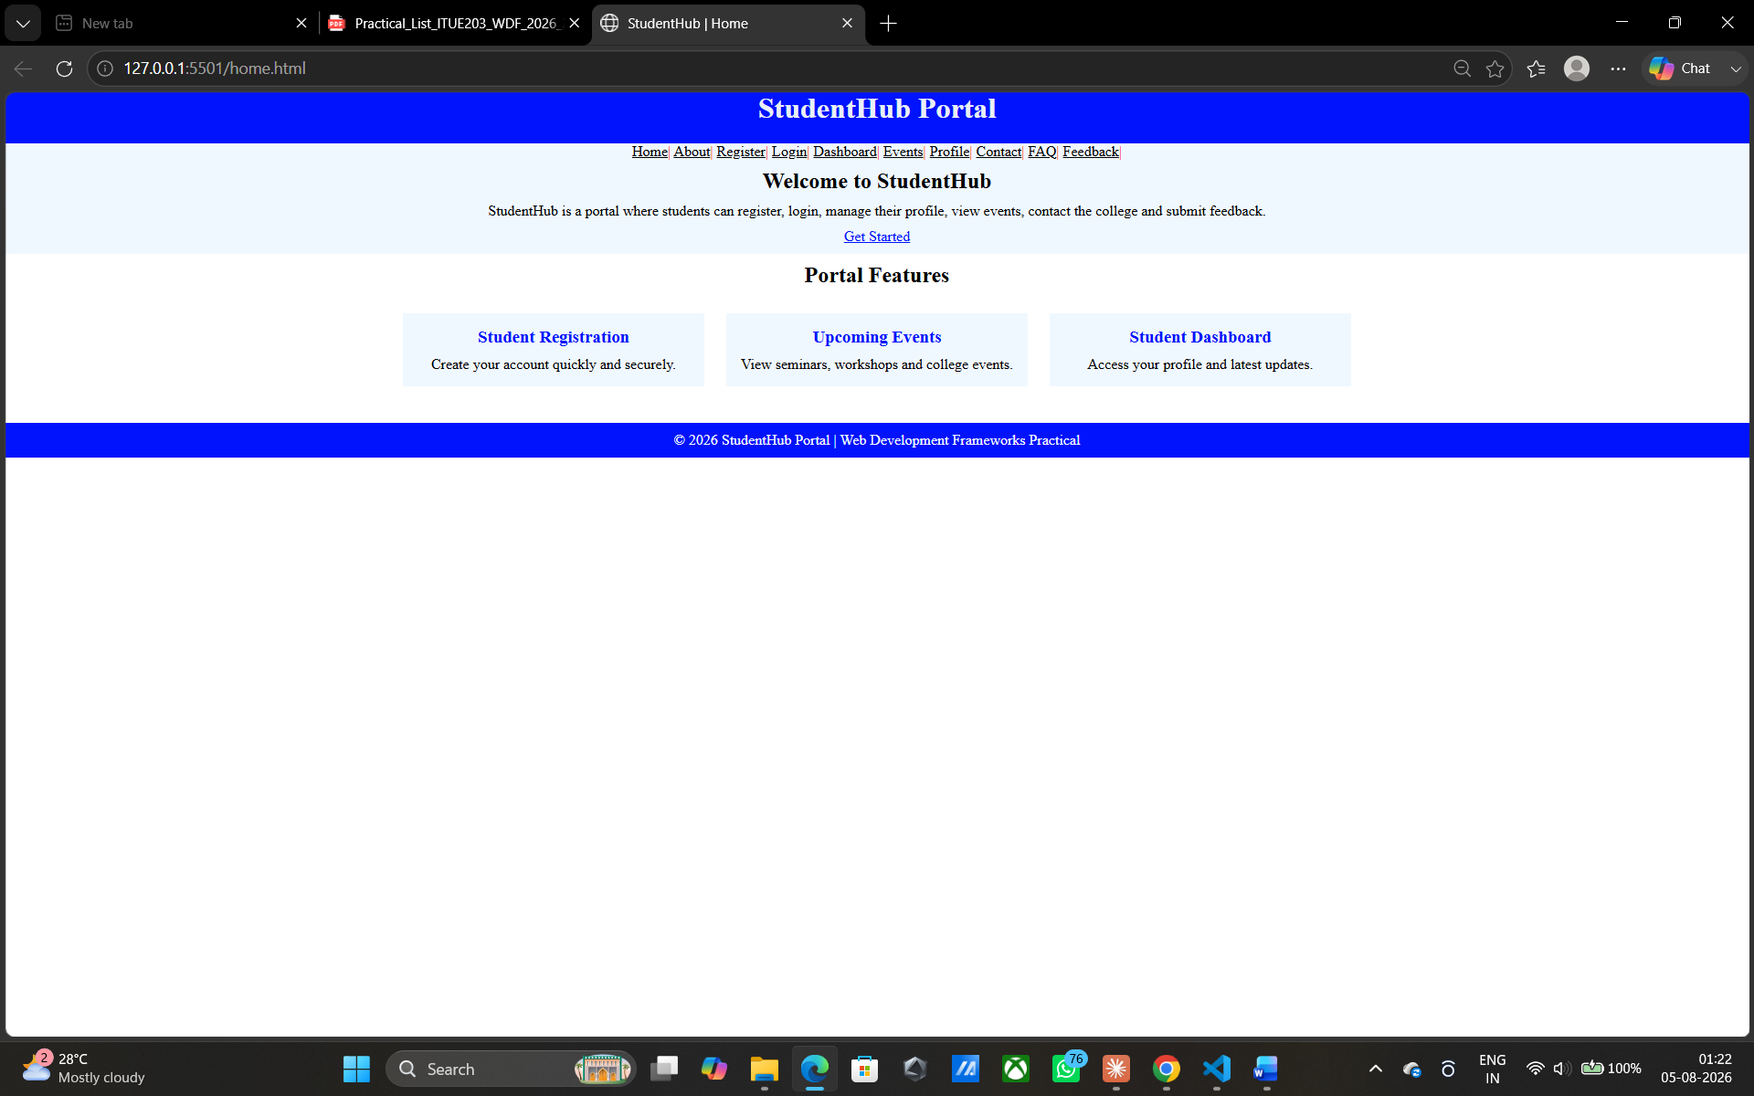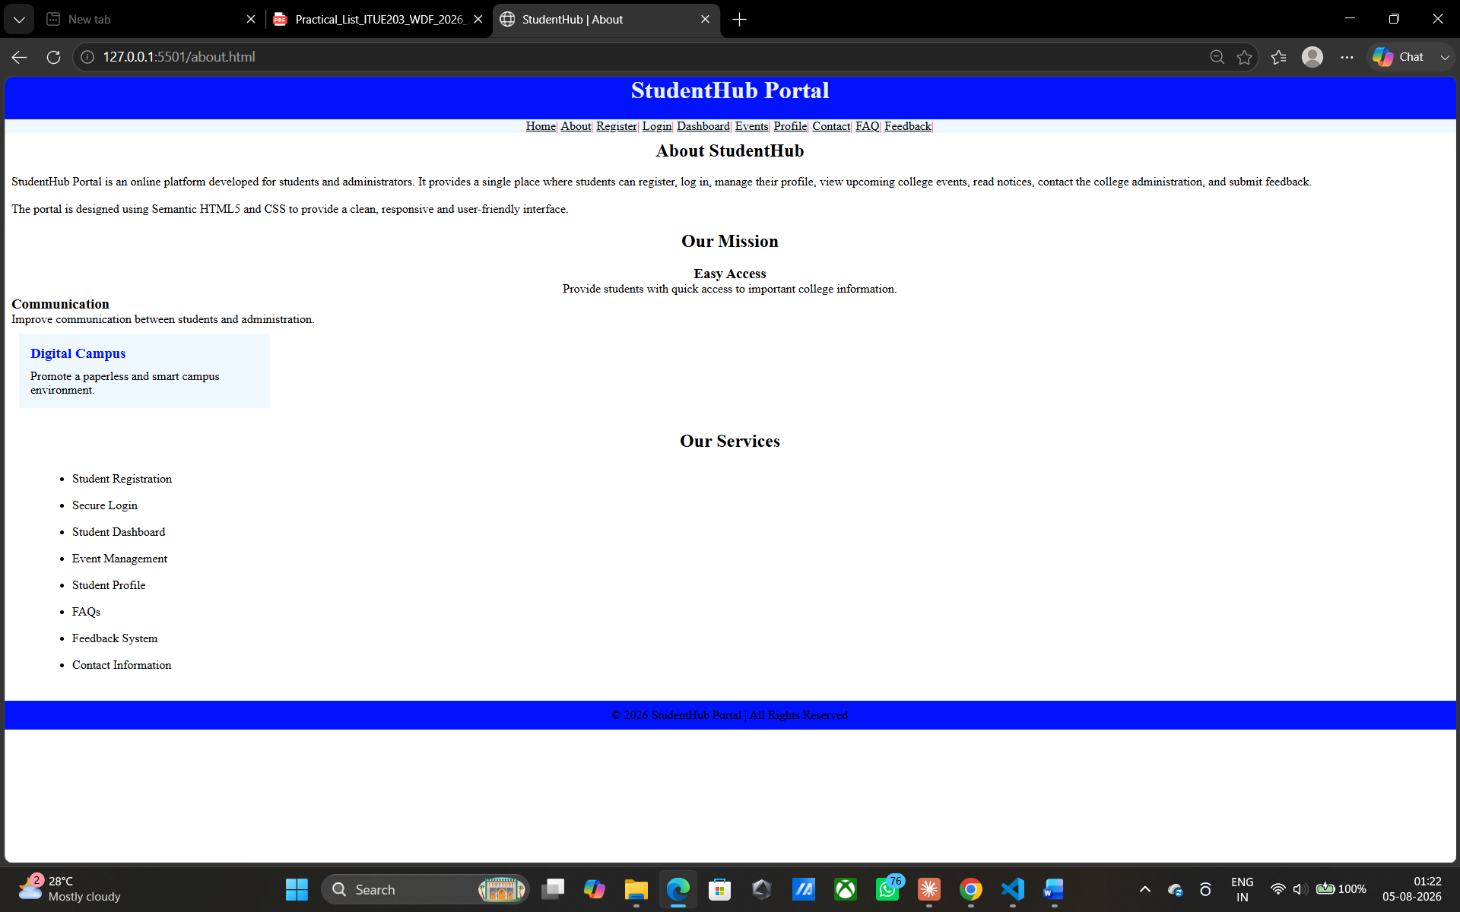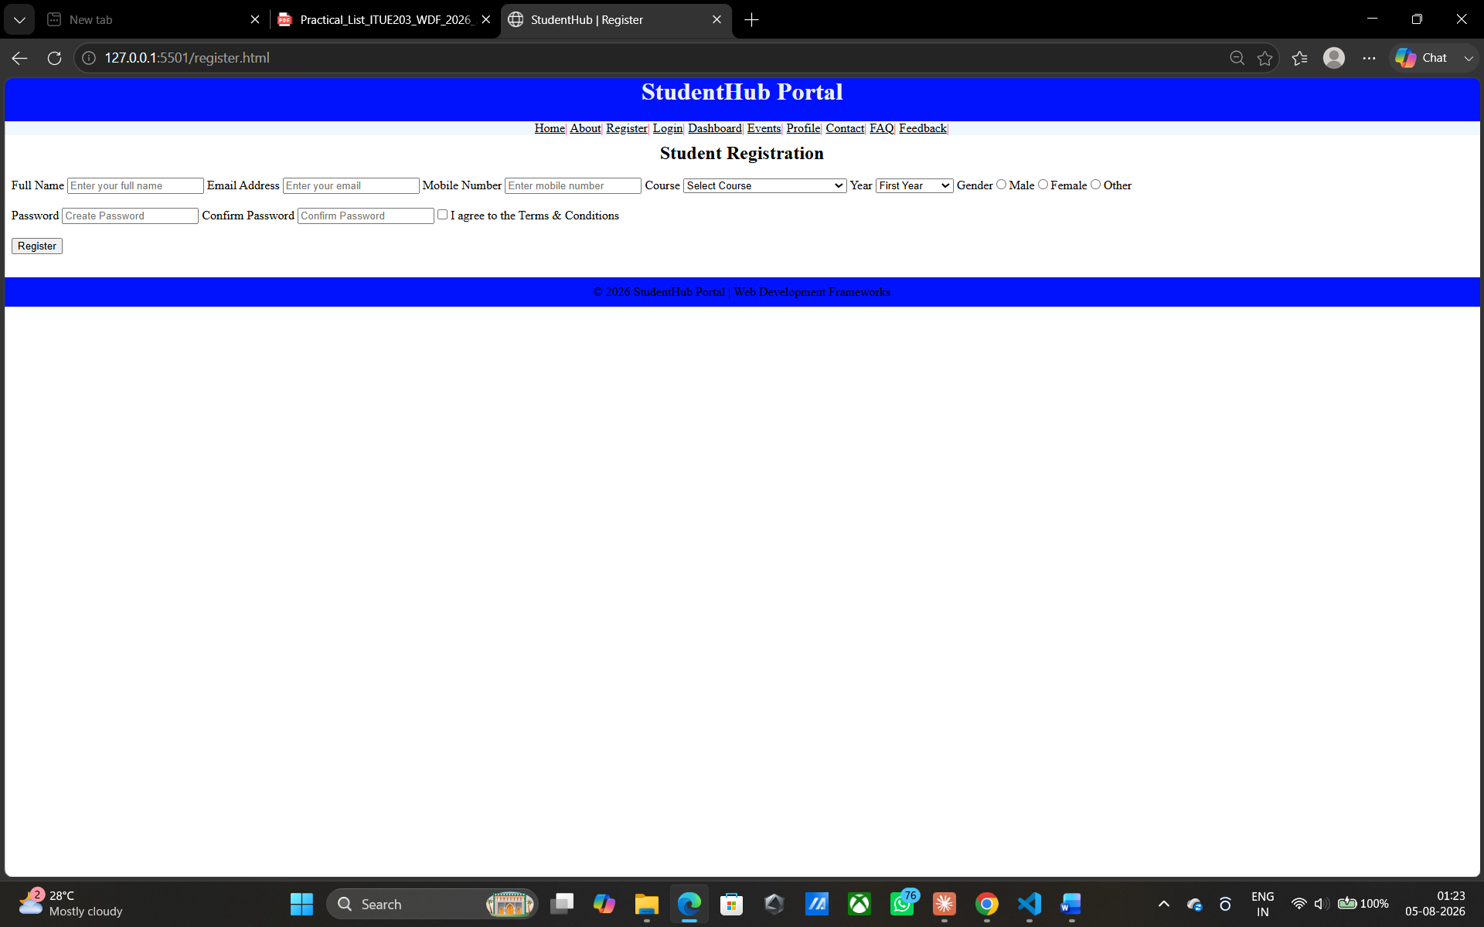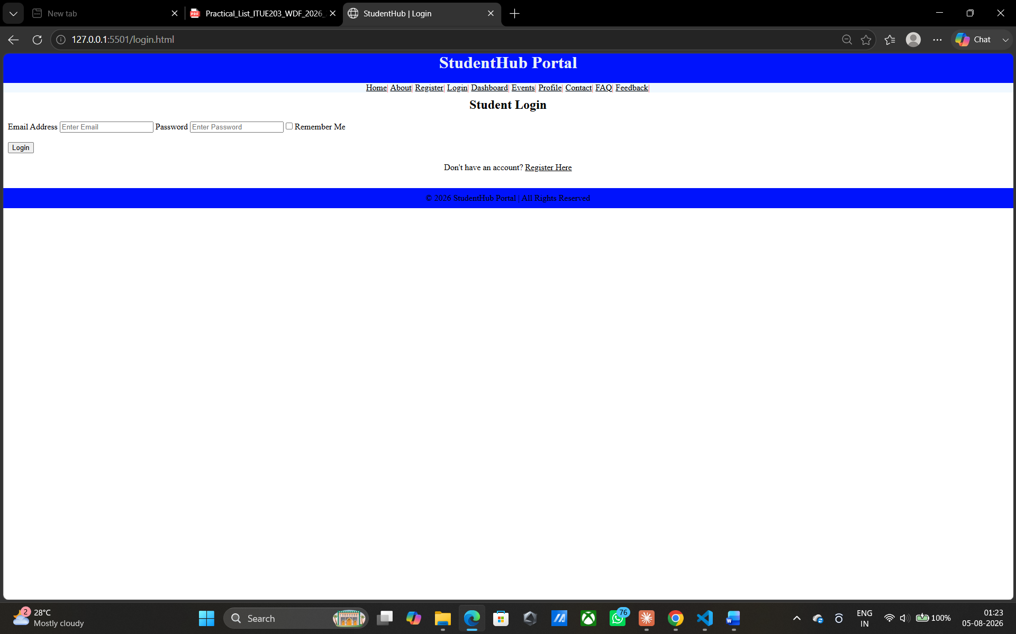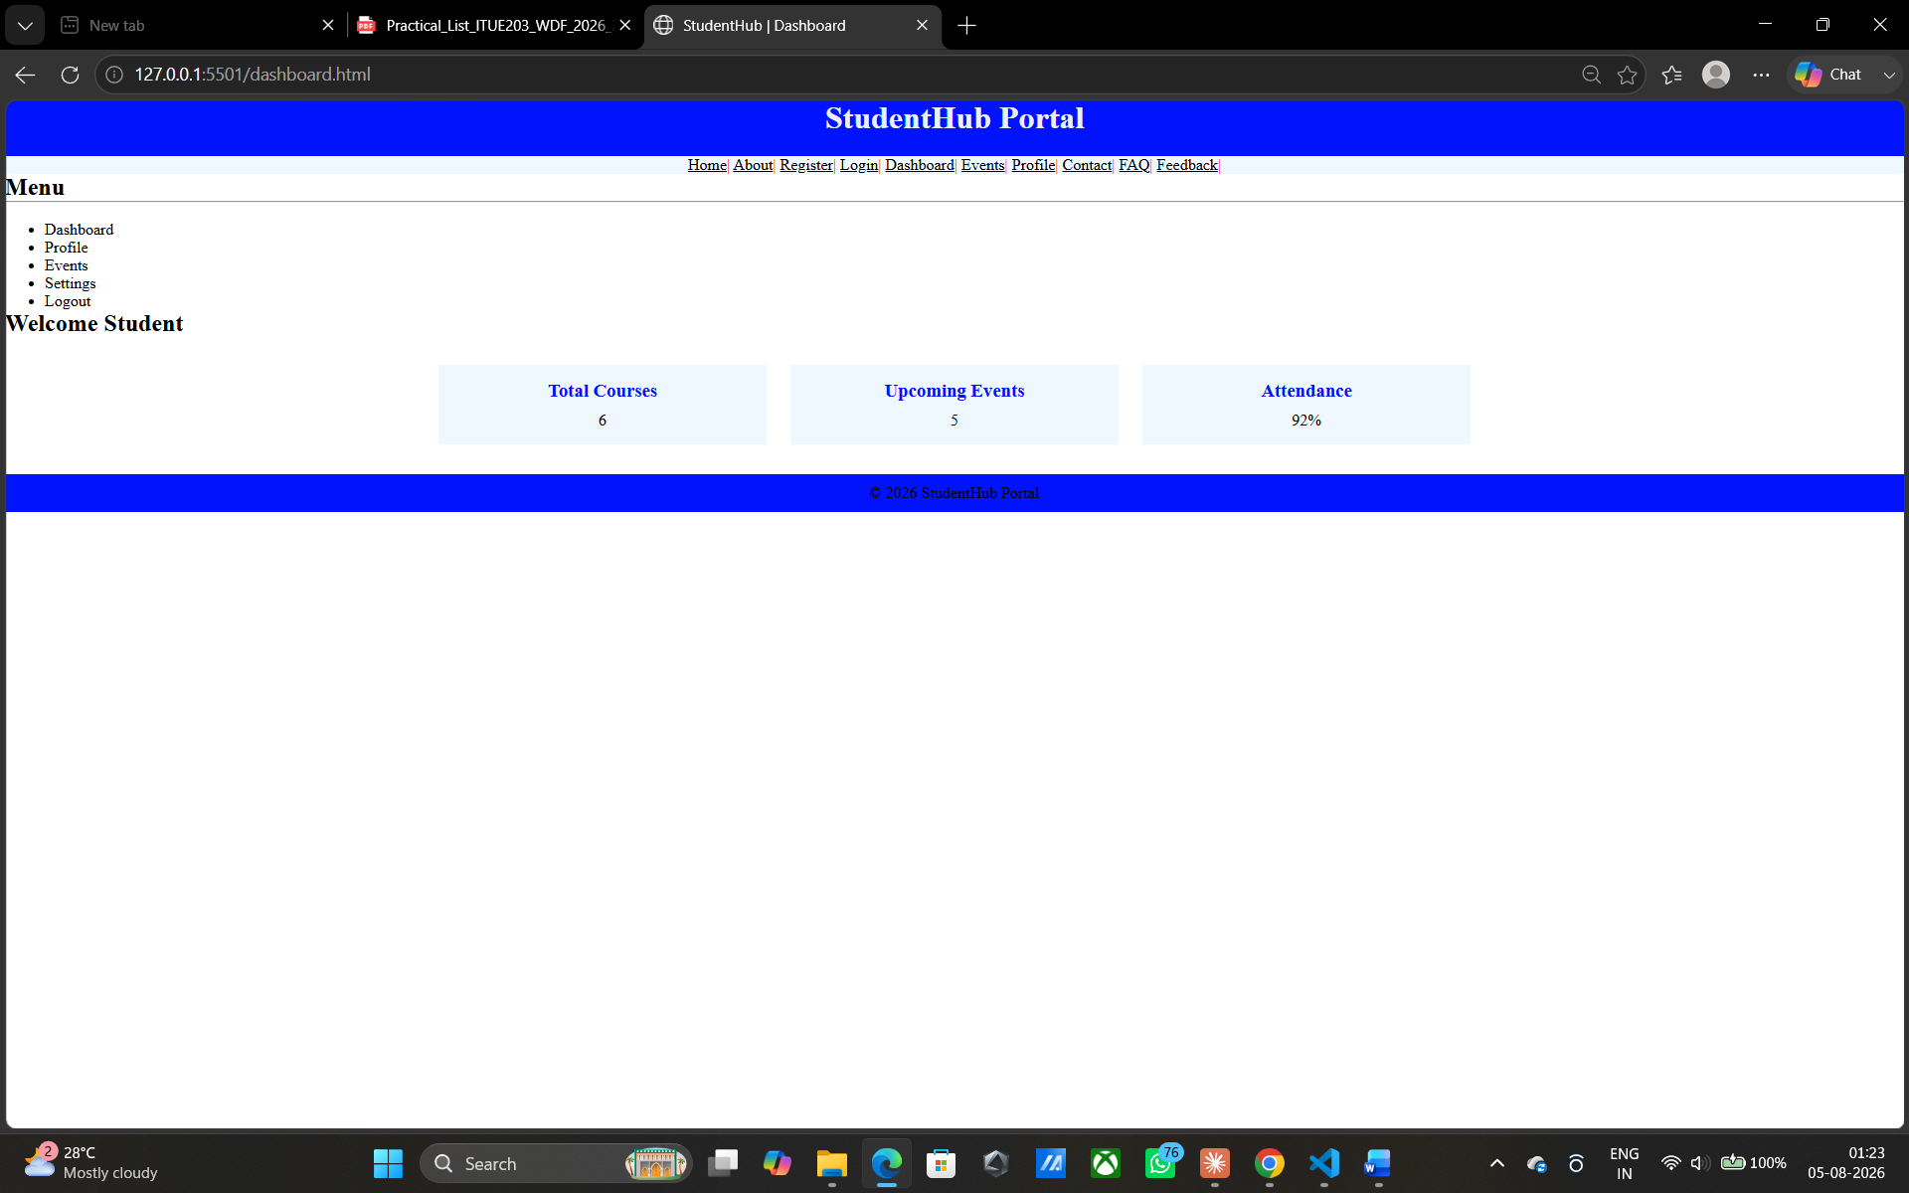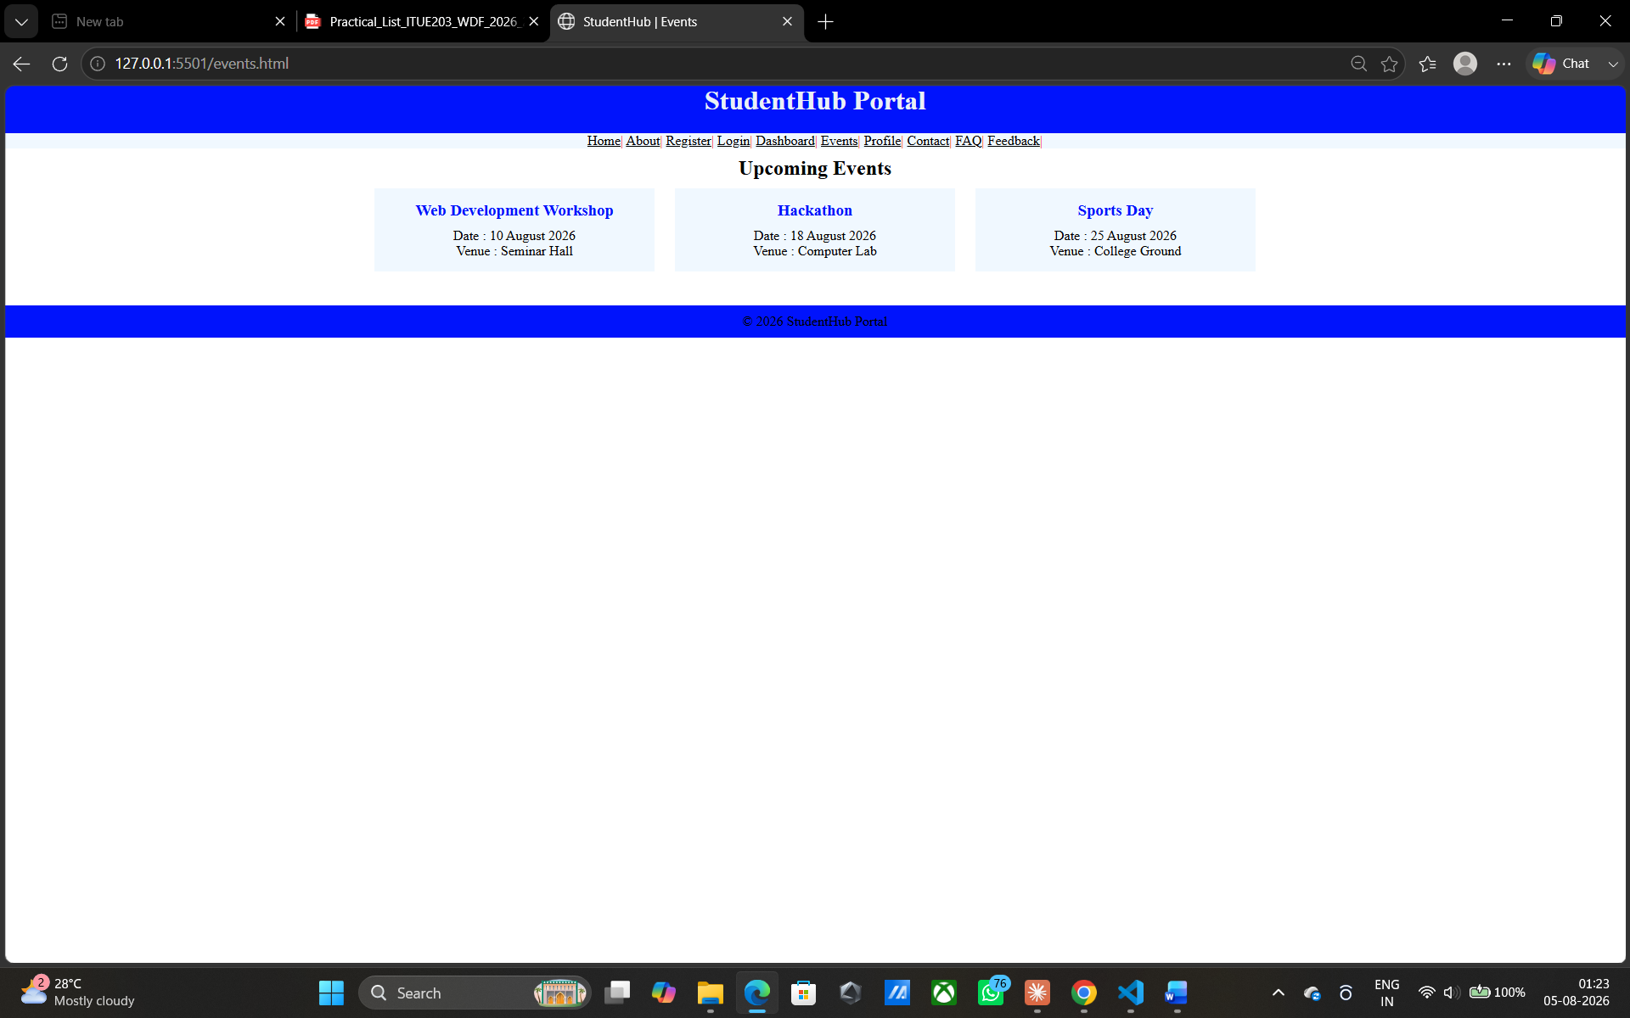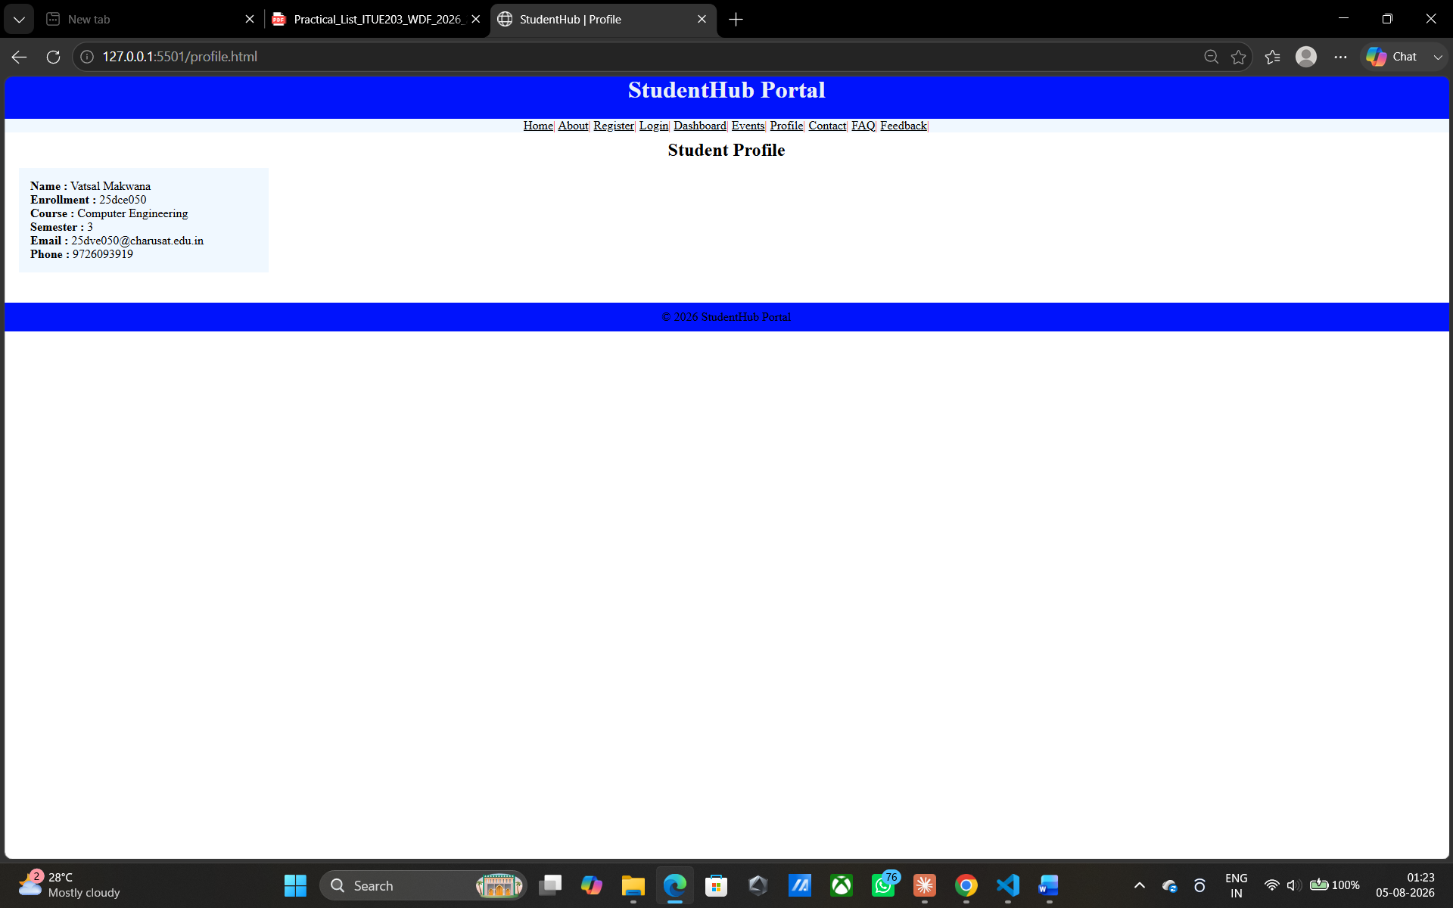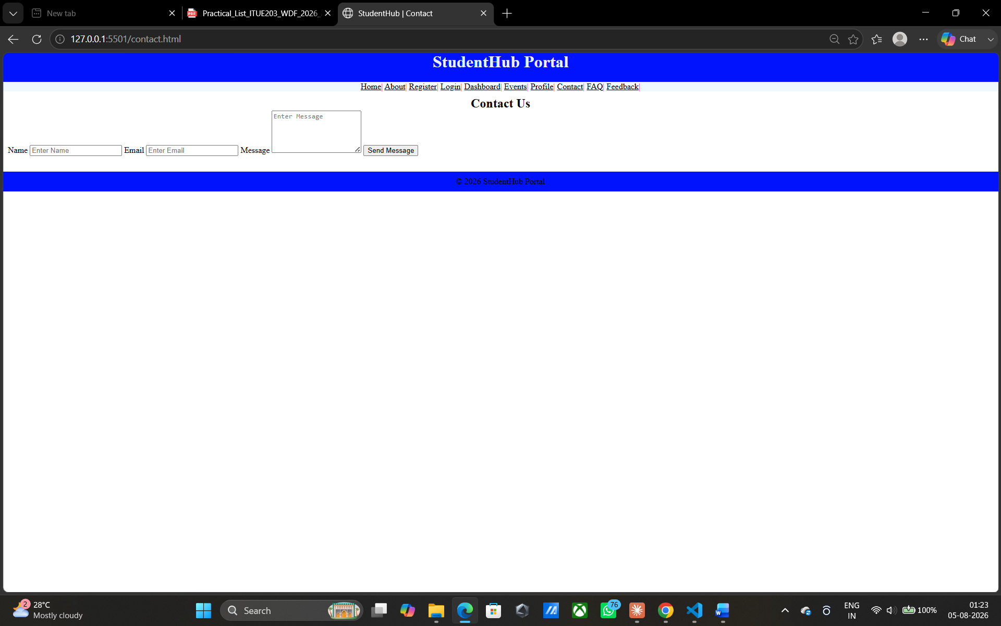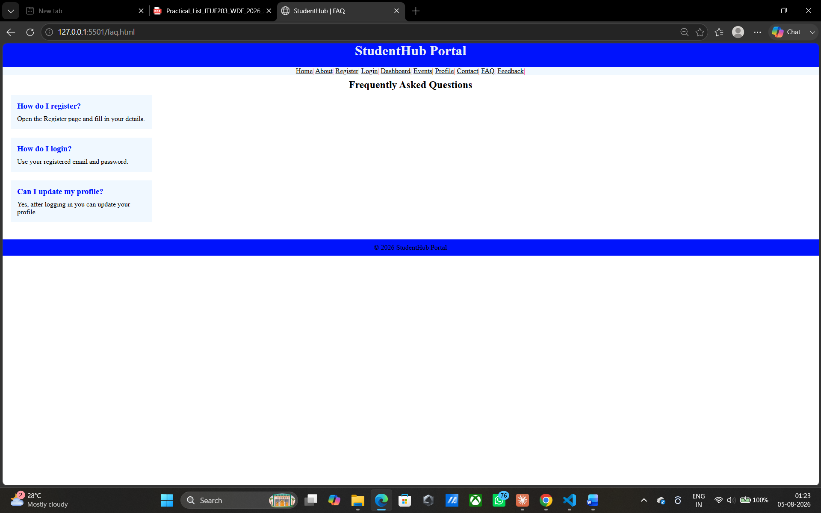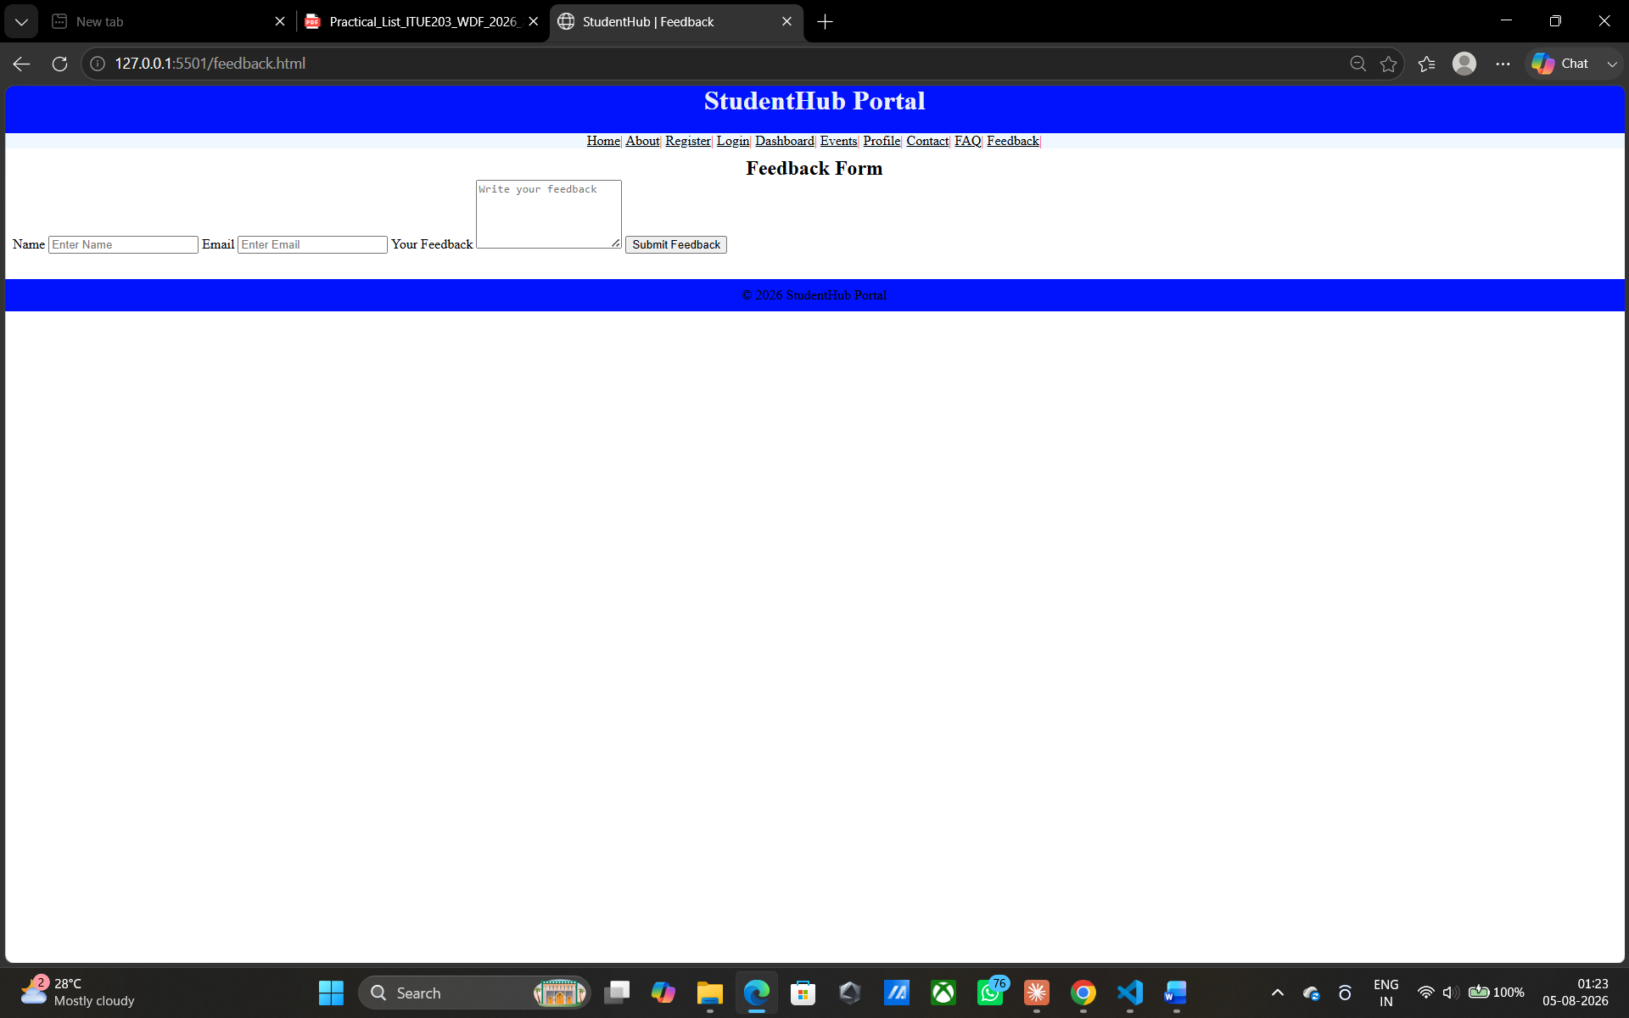

GitHub Repository Link:
https://github.com/vatsal1950/basics-of-html.git

Challenges Faced:
Maintaining consistency across 10 pages — Applying the same responsive grid/flex structure to every page individually risked inconsistencies. Resolved by building one shared/common CSS stylesheet (with reusable classes for nav, cards, containers) linked across all 10 pages instead of writing separate styles per page.

Learning Outcomes:
Apply CSS Grid and Flexbox to build responsive, multi-device layouts across an entire 10-page website.
mplement a mobile-first design approach using media queries for mobile, tablet, and desktop breakpoints.

Faculty Remarks:

